Лабораторная работа №2

*Выполнил: Шардт М.А.*

# Задание 1

1. Изображение

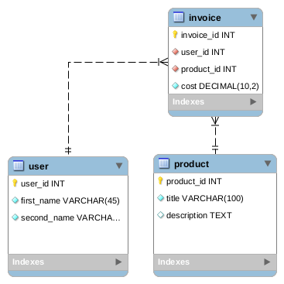

1. Github Gist

<https://gist.github.com/mxschardt/8a6a859a74f01ae9b42ad431ac97dbfc>

1. Фрагмент запроса

| CREATE TABLE IF NOT EXISTS `mydb`.`invoice` (  `invoice_id` INT NOT NULL AUTO_INCREMENT,  `user_id` INT NOT NULL,  `product_id` INT NOT NULL,  `cost` DECIMAL(10,2) NOT NULL,  PRIMARY KEY (`invoice_id`),  INDEX `_idx` (`user_id` ASC) VISIBLE,  INDEX `fk_procduct_id_idx` (`product_id` ASC) VISIBLE,  CONSTRAINT `fk_user_id`  FOREIGN KEY (`user_id`)  REFERENCES `mydb`.`user` (`user_id`)  ON DELETE CASCADE  ON UPDATE CASCADE,  CONSTRAINT `fk_procduct_id`  FOREIGN KEY (`product_id`)  REFERENCES `mydb`.`product` (`product_id`)  ON DELETE CASCADE  ON UPDATE CASCADE) ENGINE = InnoDB |
| --- |

**Задание 2**

Изображение

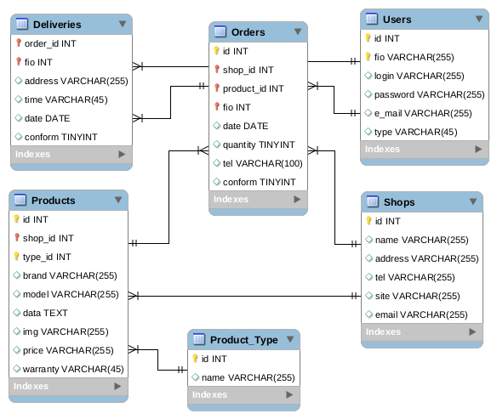

Гист

<https://gist.github.com/mxschardt/967ffc52ea2589074c05306bfc1db505>

Фрагмент

| CREATE TABLE IF NOT EXISTS `mydb`.`Orders` (  `id` INT NOT NULL AUTO_INCREMENT,  `shop_id` INT NOT NULL,  `product_id` INT NOT NULL,  `fio` INT NOT NULL,  `date` DATE NULL,  `quantity` TINYINT NULL,  `tel` VARCHAR(100) NULL,  `conform` TINYINT NULL,  PRIMARY KEY (`id`, `product_id`, `fio`, `shop_id`),  INDEX `fk_shop_id_idx` (`shop_id` ASC) VISIBLE,  INDEX `fk_product_id_idx` (`product_id` ASC) VISIBLE,  INDEX `fk_fio_idx` (`fio` ASC) VISIBLE,  CONSTRAINT `fk_fio`  FOREIGN KEY (`fio`)  REFERENCES `mydb`.`Users` (`id`)  ON DELETE NO ACTION  ON UPDATE NO ACTION,  CONSTRAINT `fk_shop_id`  FOREIGN KEY (`shop_id`)  REFERENCES `mydb`.`Shops` (`id`)  ON DELETE NO ACTION  ON UPDATE NO ACTION,  CONSTRAINT `fk_product_id`  FOREIGN KEY (`product_id`)  REFERENCES `mydb`.`Products` (`id`)  ON DELETE NO ACTION  ON UPDATE NO ACTION) ENGINE = InnoDB |
| --- |

**Задание 4**

